Protostar, Initial mass, Main Sequence
- A protostar forms from a cloud of gas in space which collapses under gravity.
- As the gas collapses it heats up and begins to shine.
- Eventually the core becomes so hot (10 million degrees) and dense that nuclear chain reactions begin - at this point the star enters the main sequence. It will fuse hydrogen into helium during this stage.
- E = mc²
- A star spends most of its life on the main sequence. Its initial mass determines how large and bright the star will be, which also indicates its position on the HR diagram. The largest, brightest stars burn their fuel the fastest and have the shortest lives. Faint red dwarfs live the longest.

Red Giant - stable element "shells"
- At the end of its time on the main sequence, when the hydrogen fuel in the core of the star is exhausted, the star will briefly collapse, causing the core to become more dense and hotter. When the core temperature reaches 100 million degrees, the helium in the core begins converting to carbon. Hydrogen in the outer layers re-ignites.
- Further stages of heavier element burning may occur depending on the remaining mass of the star. Shells of heavy-element burning build up around the core.
- During the red giant stages, the outer envelope of gas at the surface of the star becomes cooler and rarefied. A red supergiant such as Betelgeuse is 400 times the diameter of our Sun. When our Sun becomes a red giant, it will probably encompass the orbits of Mercury and Venus.
- A star loses mass throughout its lifetime via nuclear fusion and the stellar wind.

Fate of the Star
- The remaining mass of the core of the star determines its eventual fate.
- Red dwarf stars with less than half a solar mass do not achieve red giant status - they begin to fade as soon as their hydrogen fuel is exhausted.

White dwarfs, planetary nebulae
Our Sun, and any star with similar mass, will fuse to carbon and, possibly, oxygen and neon before shrinking to become a white dwarf (about the size of the Earth) surrounded by a planetary nebula.

Supernovae
Larger stars continue to fuse elements all the way to iron. Beyond iron, energy is no longer released. A star that still has more than 1.44 solar masses will end its life in a supernova explosion, leaving a remnant billions of times denser than a white dwarf.
- Up to 3 solar masses - star will produce a neutron star.
- Greater than 3 solar masses - star will become a black hole.

Protostar

Main Sequence

Red Giant

White Dwarf

Variable

Red Giant

Supernova

Neutron Star

Black Hole

STELLAR REMNANTS
Neutron Stars - Pulsars
Pulsars were first discovered 1967 by Jocelyn Bell. She noticed a regularly pulsing source of radio waves. Earliest discoveries named LGM 1 to LGM 4. But these turned out to be rotating, highly magnetized neutron stars.

Features:
- 1.4 to 3 solar masses in 10 to 30 km radius.
- 10¹⁴ density of water - a pinhead of material would weigh a million tons.
- Pulses typically every second (0.033 sec to 4.2 sec).

Examples:
- Crab Pulsar
  - Remnant of 1054 supernova
  - Pulses every 1/30 second (radio, optical and x-rays)
- Vela Pulsar
  - Pulses 11 times per second.
  - Associated with Vela supernova remnant.

Black Holes
The known laws of physics are unable to describe what is inside a black hole (bizarre distortions of space-time and incalculable densities of matter).
Everything inside the Schwarzchild radius can never escape - including light.

Candidates: 14 known x-ray binaries in Milky Way, from 3 to 12 solar masses.
- Cygnus X1, 11 solar masses
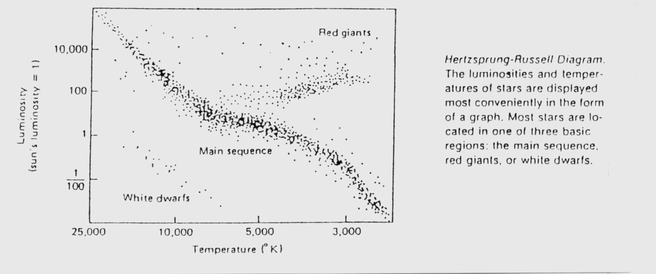
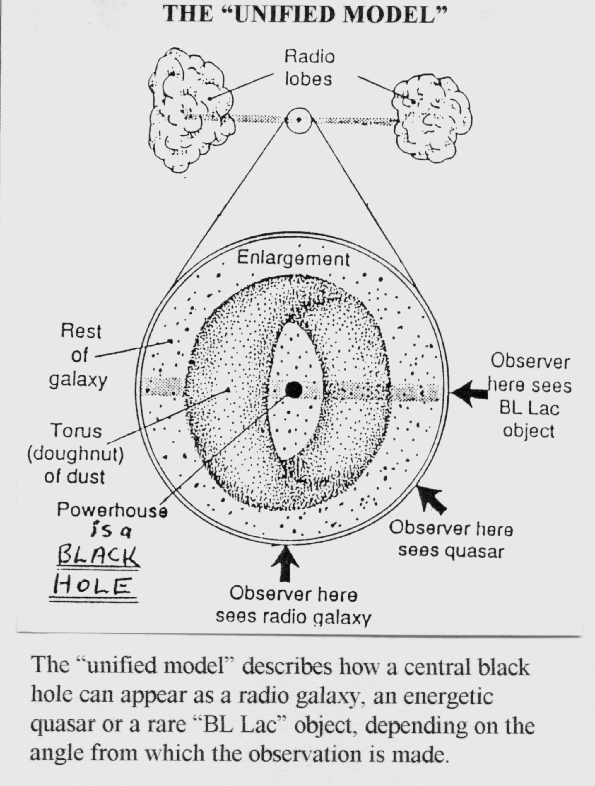
- V404 Cygni, 12 solar masses

LIVES OF STARS
Protostar, Initial mass, Main Sequence
A protostar forms from a cloud of gas in space which collapses under gravity.
As the gas collapses it heats up and begins to shine.
Eventually the core becomes so hot (10 million degrees) and dense that nuclear chain reactions begin - at this point the star enters the "main sequence". It will “burn” hydrogen into helium during this stage.
A star spends most of its life on the main sequence. Its initial mass determines how large and bright the star will be, which also indicates its position on the HR diagram (see below). The largest, brightest stars burn their fuel the fastest and have the shortest lives. Faint red dwarfs live the longest.

Red Giant - stable element "shells"
At the end of its time on the main sequence, when the hydrogen fuel in the core of the star is exhausted, the star will briefly collapse, causing the core to become more dense and hotter. When the core temperature reaches 100 million degrees, the helium in the core begins converting to carbon. Hydrogen in the outer layers re-ignites.
Further stages of heavier element burning may occur depending on the remaining mass of the star. (A star loses mass throughout its lifetime through radiation and the stellar wind.)
During these stages, the outer envelopes of gas at the surface of the star become cooler and rarefied, expanding as they do so. A red supergiant such as Betelgeuse is 400 times the diameter of our Sun. When our Sun becomes a red giant, it will probably encompass the orbits of Mercury and Venus.

Fate of the Star
The remaining mass of the core of the star determines its eventual fate.
Stars with less than half a solar mass do not achieve red giant status - they begin to fade as soon as their hydrogen fuel is exhausted.

White dwarfs, planetary nebulae
Some are not massive enough to burn elements beyond helium. These will become small white dwarfs, and the cast-off gas will glow as a "planetary nebula".

Supernovae
Larger stars with masses greater than 1.44 Solar masses will explode in a supernova explosion, leaving a remnant billions of times denser than a white dwarf. Up to 3 solar masses will produce neutron star. Greater than 3 solar masses will become black holes.

Page 2
STELLAR EVOLUTION
H-R Diagram from Macquarie University 1995 “School of Astronomy”

STELLAR REMNANTS
Neutron Stars and Pulsars
Pulsars were first discovered 1967 by Jocelyn Bell. She noticed a regularly pulsing source of radio waves. Earliest discoveries named LGM 1 - 4. But these turned out to be rotating, highly magnetized neutron stars.

Features: 1.4 to 3 solar masses in 10 - 30km radius.
10¹⁴ density of water - a pinhead of material would weigh a million tons.
Pulses typically every second (0.033 sec - 4.2 sec).

Examples: Crab Pulsar – Remnant of 1054 supernova
Pulses every 1/30 second (radio, optical and x-rays) Vela Pulsar – Pulses 11 times per second. Associated with Vela supernova remnant.

Black Holes
The known laws of physics are unable to describe what is inside a black hole (bizarre distortions of space-time and incalculable densities of matter).
Everything inside the Schwarzchild radius can never escape - including light.

Best candidates: M87, 50 million light years away in Virgo. (3 billion solar masses.)
Cygnus X1
V404 Cygni - binary system

There are few good candidates for black holes because mass loss in large stars may be too rapid to leave a remnant of enough mass to become a black hole.
Page 2
STELLAR EVOLUTION
STELLAR EVOLUTION

Protostar

Main Sequence

Red Giant

White Dwarf Variable
Red Giant

Supernova

Neutron Star Black Hole
Unified Model diagram from Macquarie University 1994 “School of Astronomy”
THE “UNIFIED MODEL”
The “unified model” describes how a central black hole can appear as a radio galaxy, an energetic quasar or a rare “BL Lac” object, depending on the angle from which the observation is made.

